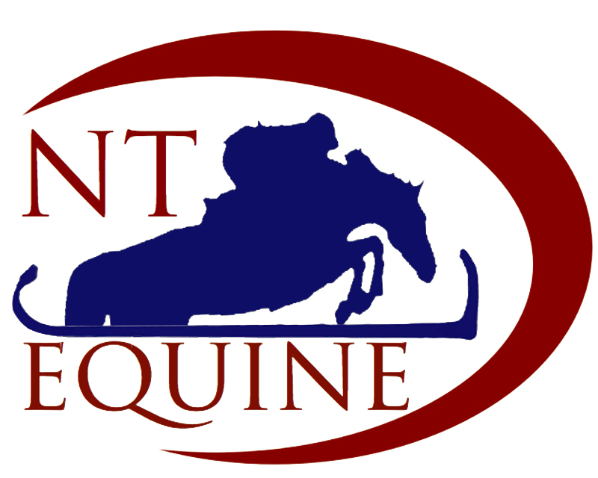

Sales Agreement

Name of Purchaser:

Date:

1. In consideration of the sum of £. the Seller, NT Equine(Acting either as seller or agent) agrees to sell and the Purchaser agrees to purchase (Name of horse):
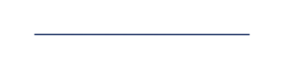
The horse remains property of ( name of owner) until sale is completed

2. Remainder of Payment (less £200 deposit) needs to be paid in cleared funds

3. Upon the Seller’s receipt of the Purchase Price (as cleared funds):-

• The ownership of the Horse shall pass from the Seller to the Purchaser.
• The deposit (£200) is to secure said horse from other interested parties and if the purchaser decides not to proceed with the purchase of the horse the deposit shall be retained by NT Equine. The deposit will be returned in full if said horse does not pass the vetting required by the purchaser.
• The Seller strongly recommends that the Purchaser adequately insures the Horse (preferably covering third party liability, death, theft, veterinary fees and loss of use) prior to or immediately upon payment.
• Responsibility for any loss, damage or injury whatsoever caused by the Horse shall pass to the Purchaser.
• The Seller will release possession of the Horse to the Buyer or his/her employee/agent together with all original documents.
• The Purchaser (or another person designated by the Purchaser) in coordination with NT Equine will arrange for the transportation of the Horse from the premises, (at the Seller’s and the Purchaser’s convenience) at the Purchaser’s expense.
• Where the Horse is not collected immediately upon ownership of the Horse passing from the Seller to the Purchaser, the Purchaser agrees to indemnify the Seller against all costs incurred in caring for the Horse (veterinary costs etc.) until the horse is collected by the Purchaser or his/her employee/agent. Any loss, damage or injury how so ever caused by the Horse whilst the Horse is at NT Equine’s premises awaiting collection by the Purchaser shall be the Purchaser’s responsibility.
• The Purchaser will arrange payment and for removal of the horse within 24 hours of the vetting. If the Purchaser chooses to not have the horse vetted we ask that they arrange the remainder/full payment of the horse within 24 hours of deposit being paid. After this period livery charges will be incurred at the current rate.

• The Purchaser acknowledges that :
• The Seller makes no representation as to the past, current or future health, fitness, performance, ability or material defects which the Purchaser acknowledges have been disclosed by the Seller (e.g. splints/unsafe in traffic/weaves/cribs)

…………………………………………………………………………………………………………………………………………………………
…………………………………………………………………………………………………………………………………………………………

• The Purchaser has inspected the Horse and is satisfied with its health, fitness and ability.
• The Purchaser acknowledges that the Horse is open to veterinary inspection, which the Purchaser may instruct a vet to perform at his discretion. In accepting or declining the opportunity to have the Horse inspected by a vet, the Purchaser waives all rights to bring a claim against the Seller in respect of any matter revealed or which should have been revealed by the vet during that inspection.
• The Horse is purchased for the purposes of (delete as applicable) showing / dressage / show jumping / eventing /breeding / hacking/ hunting/riding club/ general riding / companion / other.
• The Purchaser must satisfy themselves that the Horse is suitable for its intended purpose. The Purchaser is welcome to ride the horse in the school and take the horse out for hacks before purchase but all riding is undertaken at the rider’s own risk.
• The Purchaser accepts that horses are unpredictable by nature and that horse riding is a high-risk sport. The Seller is unable to predict how any horse will mature or develop in new ownership however the Seller will provide full details of the Horse’s routine and current exercise/feed/tack requirements in order that the Horse has the best opportunity of settling into its new home.
• The purchaser is offered a 7-day money back guarantee less 10% if the horse is returned. The horse must be returned in the same condition as it left the yard to receive your money back.

4. If the purchaser wishes NT Equine to take the horse back to sell on their behalf, and NT Equine has the capacity to take the horse in to sell, the following charges will apply –

• livery charged at the current rate.
• 10% of the sale price
• If separate sales advertising is required, the costs will be charged to the Purchaser.
- If the farrier or the vet is required the costs will be charged to the purchaser.
5. It is understood that NT Equine is transient yard and we therefore we highly recommend that all new purchases are kept in a quarantine environment for the first two weeks in their new homes . NT Equine can not accept any responsibility for horses accident or illness once the horses have left the premises.

Please sign below to confirm that you have read and understood the above terms and that you are happy to proceed.

Signed Purchaser: Date:

